* All about natural selection
* Before looking at allelic probability w/o natural selection – unrealistic
* Genetic variation is important because:
  + Different alleles and genotypes affect pop’s ability to survive and thrive
  + Informative to conservation efforts and makes these efforts more directional and effective
* Fitness = avg. number of offspring produced by individuals of a certain genotype
  + Viability and fertility are the factors driving selective differences between genotypes
  + Fitness = (viability)(fertility)
  + Relative fitness – based on the total number of expected progeny for each genotype
  + Relative fitness is a function of the number of progeny
* To calculate fitness at a single locus with two alleles: p’ = p + (delta)p
  + *w* is the avg fitness in the population
  + Avg fitness of population = fitness of each genotype weighted by its frequency
* 3 methods of natural selection w/ constant fitness:

1. Directional selection: when one allele is always at a selective advantage; allele becomes fixed, can be dominant, intermediate, or recessive

* Rate of change in allele frequencies affected by dominance whereas in directional selection the dominance of the allele does not matter;
* dominance, intermediate and recessive does not refer to phenotype but instead refers to the selective advantage
  + 1. In recessive directional selection, one allele is being selected for, but when in a heterozygous state it does not have the same fitness as when it's in the homozygous state; advantage only happens in one genotype state so it takes longer to reach fixation relative to dominant and intermediate
       1. Only when in homozygous 11 state is there a selective advantage, otherwise equal to other states
    2. In dominant directional selection, heterozygote and homozygote of allele 1 have the same fitness, so it reaches fixation at the fastest rate

Dominant : w11 = w12 > w22

Intermediate: w11 > w12 > w22

Recessive: w11 > w12 = w22

1. Overdominance/heterozygote advantage : when the heterozygote has the best fitness

w11 < w12 > w22

* Expected to maintain both alleles in stable equilibrium
* Example 8.2: heterozygous advantage for color polymorphism in the common buzzard

→ heterozygotes have a higher rate of reproductive success, therefore the heterozygotes have a selective advantage

1. Underdominance/heterozygous disadvantage : when the heterozygote is least fit

w11 > w12 < w22

* Produces an unstable equilibrium, which will result in homozygotes becoming fixed
* Selection and hw proportions
  + Lack of departures from hw proportions does *not* mean particular locus isn’t affected by natural selection
  + Differences in fertility won't affect HW proportions; only differential survival can be tested for by testing for HW proportions
  + \*\*confusing concept\*\* sometimes even strong differences won’t cause deviations from HW proportional at a locus with 2 alleles, differential survival doesn’t cause a departure from HW proportions as long as the product of the fitness of the 2 heterozygotes equals the square of the fitness in the homozygotes
    - Condition: if enough individuals are contributing to the gene pool
    - Selection has to be strong in a directional standpoint to throw off HW equilibrium; fitness of 2 homozygotes is close to the fitness of the square of the fitness in the homozygotes
    - Heterozygote advantage reinforces HW proportions
    - “You have to really shift one genotype relative to the others” in math terms
  + “goodness of fit” test for HW proportions isn’t able to detect deviations from HW proportions that are caused by differential survival → its a way but not the best way
* Multiple alleles
  + Analyses of the effects of natural selection become increasingly complicated when a locus has more than two alleles
  + We can extend our equation to 3 alleles, but there are no set rules for 3 alleles at a single locus like there is for 2 alleles
    - Ex. heterozygous advantage/genotype could be referring to multiple heterozygous genotypes all with different fitnesses
    - MHC (major histocompatibility complex) genes are multi polymorphic with tons of alleles; code for adaptive immune system
  + Helpful tips for looking at a locus with >2 alleles:
    - There is at most one stable equilibrium for two or more alleles
    - A stable equilibrium will be reached from any starting point that contains all three alleles
    - If a stable polymorphism exists, the average fitness of the population exceeds the fitness of any homozygous; if a homozygote like this …
      * Any time alleles within a multiple allelic system get to a higher level of frequency allows for the possibility of minor alleles to be pushed towards an unstable state, resulting in the potential for drop-out and the return to a 2 allele system
* Self-incompatibility locus in plants
  + S allele that determines which plants can fertilize each other; s must be different
  + new alleles resulting from mutation have the greatest selective advantage and will most spread throughout the population although it may also be lost; eventually a return to equilibrium will be reached
    - S1, S2, and S3 alleles have an equal probability (0.33)
    - Mutated allele S4 has a great selective advantage because its able to fertilize every plant
    - Eventually all alleles will stabilize at a probability of 0.25
* Complementary sex determination in invertebrates (look at table 8.4)

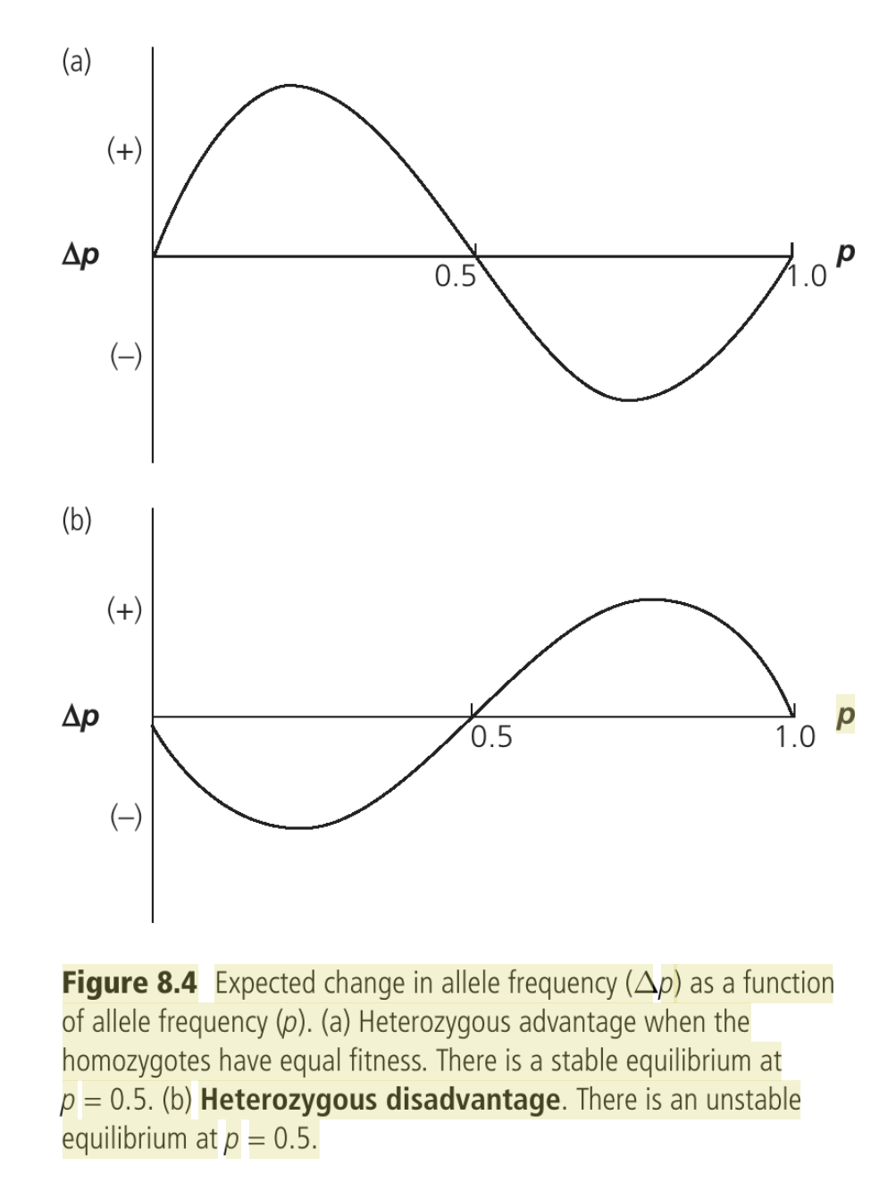

* + Many invert species have a haplodiploid mechanism of sex determination
  + Homozygous diploid at csd (similar to s allele) develop into infertile males
  + Rate alleles are advantageous because they are less likely to produce sterile homozygous males
  + Small populations are especially susceptible to producing more sterile males because genetic drift reduces allelic diversity at csd locus
  + An increase in males being produced means a decrease in females being produced, which may cause the population to decline
  + Increasing probability of extinction in small populations
* Directional selection
  + Genetic drift hinders the effects of directional selection → it can cause the effects of random genetic drift to outweigh the effects of natural selection, meaning advantageous alleles can be lost → alleles at a selective disadvantage (deleterious alleles) may become fixed → produces genetic load (mutational meltdown–continual increase in genetic load and eventual collapse of population); accumulation of deleterious alleles within the population that ordinarily would be purged
  + Drift must be opposite direction otherwise would not be differentiated
* Underdominance and drift
  + Chromosomal rearrangements are, for the most part, selected against, even if homozygotes for that chromosomal rearrangement have higher fitness
  + Genetic drift can cause alleles that are always selected against to remain present in a population
  + When allele frequency becomes unstable, natural selection kicks in to “fix” the chromosomal rearrangement
  + Factors that make a species susceptible to becoming threatened are the same factors that suggest high chromosomal variability between groups
    - *Chromosomal rearrangements that lead to aneuploidy are similarly performing to underdominance and are more common in smaller populations or population structures that favor small reproductive groups*
      * Why translocating one population from another can be detrimental; has to do with local adaptation
      * Aneuploid = part of the genome is at the wrong ploidy; ex. partial genome duplication
* Heterozygous advantage and drift (see figure 8.9)

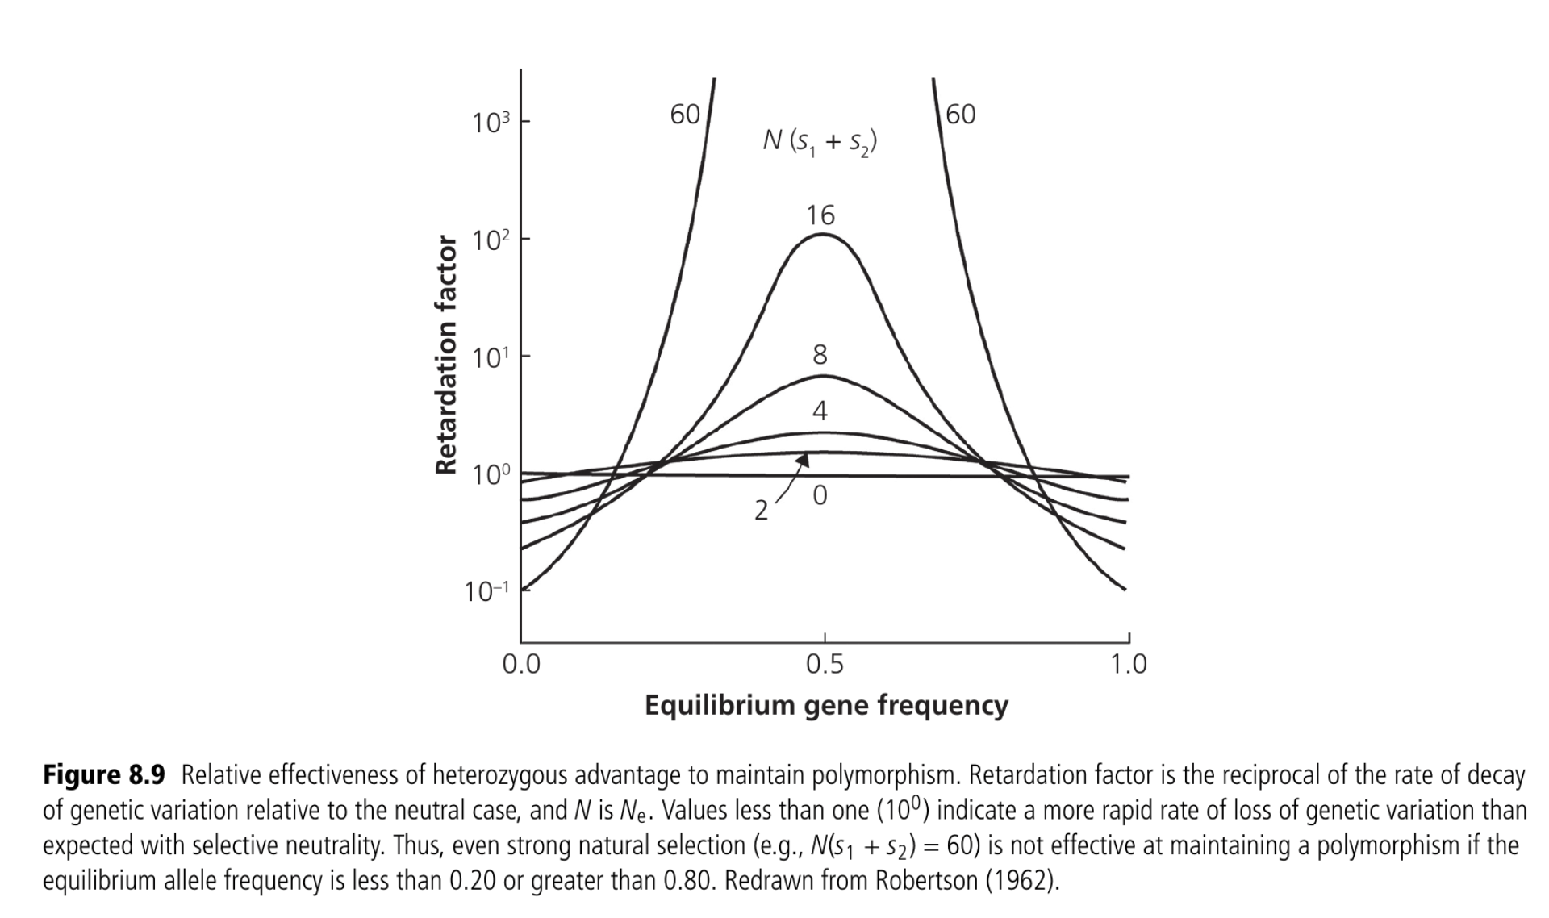

* + Overdominance can accelerate loss of genetic variance if equilibrium frequency of an allele is near zero or one
    - Retardation factor = reciprocal of the rate of decay relative to the neutral case
  + We want frequency to be as close to the middle as possible; near edges of distribution is greater likelihood of fixation of loss
* Detection of natural selection
  + Rock mice example; darker mice have a mutation on a certain gene at a certain locus, where the light color mice don’t
  + Local adaptations can be hard to find because they aren’t always present; only present themselves in events of extreme environmental differences in which selection is present; clear difference between habitat and phenotype makes it easier to detect local adaptation than more subtle adaptations
    - Predation, competition, etc. are driving factors
  + Winter storms and genetic changes in green anole lizard
    - Uncharacteristic snow storms in texas and oklahoma; survivors had genes responsible for increasing cold tolerance; one specific event had a profound effect upon allelic frequencies
    - Q: climate change causes greater extremes at both ends of the spectrum, can some genes be bidirectional and be better adapted to both extremes?
* Natural selection and conservation
  + Local adaptations have a higher presence in large populations
  + Small populations have a lesser ability to evolve to changing environments, which is crucial to their survival

Discussion questions:

Going through the example utilizing the following equations (pg. 154):

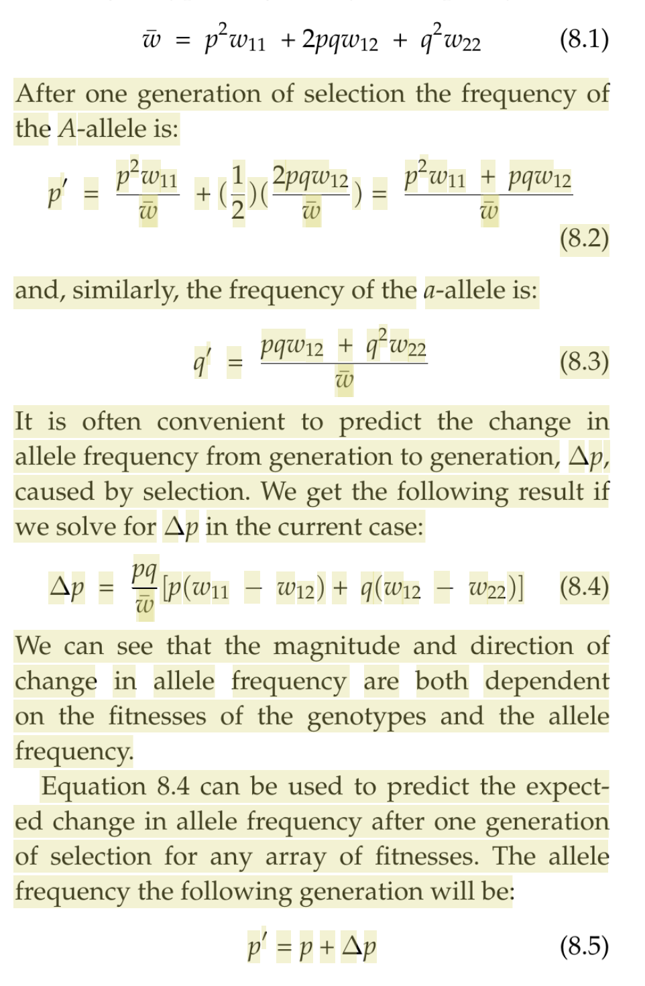

Our two imaginary allele frequencies to be used in this example:

Jk i guess we will go over this after we attempt to do the problem on our own

Cass: how do all of the equations relate to each other?

Jon: they all relate to each other because they all attempt to describe the same thing in different ways; easiest way is to use relative fitnesses and standardize to 1.0

W (bar) is the average fitness

8.1 is used to calculate the average fitness

(8.1) uses genotype frequencies to calculate genotypes frequencies

P’ = new allele frequency = 8.2

(8.1 - 8.3 focuses on one generation)

8.4 is how you do this if you want to know the change in allele frequency from generation to generation

New allele frequency = old allele frequency + change

Delta p = dp/dt (p over time)

Use 8.4 to find delta p so that we can then plug that into 8.5

Discussion q’s:

1. Describe local adaptation and discuss importance
2. Why are allele frequency distributions at neutral loci more useful when describing effective population sizes and exchanges in populations than adaptive loci?
3. Discuss possible reasons why fitness might be so hard to estimate in natural populations?
   1. Local adaptations come out in extreme stress
   2. Hard to know the total reproductive output in an individual and how many of their offspring reach reproductive potential
      1. That's why most estimates are done on plants
4. Discuss what absolute fitness is and its relationship to relative fitness.
   1. See table on page 154
      1. Viability and fertility are observed values
      2. Absolute fitness = viability x fertility
      3. Absolute fitness of that genotype/highest absolute fitness value = relative fitness
         1. Relative fitness is just the standardization of fitness in general
            1. “How many more relative to others can it produce?” can be used to compare between populations and between species
5. Can it be said that overdominance typically maintains diversity?
   1. *Unequivocally* yes
6. Why might heterozygous advantage in natural populations be relatively rare?
   1. No good answer, everyone is stumped
7. Figure 8.4 – what is going on?
   1. Delta p = change in allele frequency
   2. Expected change relative to the frequency of p
   3. Top graph (a) → heterozygous advantage; allele frequencies remain near 0.5 and is maintained
   4. Bottom graph (b) → heterozygous disadvantage; allele frequencies get out of hand and then come back to equilibrium at 0.5
8. Can it be said that underdominance negatively affects diversity?
   1. Yeah
9. How might frequency-dependent selection maintain genetic variation in natural populations?
   1. Figure 8.7
   2. Rare is positively selected for until its no longer rare